

INDIVIDUAL ASSIGNMENT

COMP40004

**WEB DEVELOPMENT AND OPERATING SYSTEMS-1**

**CFK23A1COM**

HAND OUT DATE: 3nd week

HAND IN DATE: ASSIGNMENT2: 19th Jan 2024

WEIGHTAGE: ASSIGNMENT 2: 30%

**INSTRUCTION TO CANDIDATES:**

1. **Students are advised to underpin their answers with the use of references (cited using the Harvard Name System of Referencing).**
2. **Late submission will be awarded zero (0) unless Extenuating Circumstances (EC) are upheld.**
3. **Cases of plagiarism will be penalized**
4. **Assignment presentation should be submitted in the form of softcopy and hardcopy both; modeling work should be submitted in softcopy form**

Table of Contents

Project Introduction 3

What I Learned 4

Challenges and solutions 5

Desktop Wireframes 8

Mobile Wireframes 15

Conclusion 22

# Project Introduction

Background

I began on this web development assignment with the goal of creating a website about Sri Lankan Wildlife. The site is designed to have a minimum of 7 HTML pages, covering an introduction to Sri Lankan Wildlife, specific wildlife locations, the dept of wildlife conservation, details about the Sri Lankan leopard, information about indigenous animals, and dedicated pages for Yala and Wilpattu national Parks.

Project Scope

The project scope included the use of pure HTML and CSS, with restrictions on external libraries, except for Tailwind CSS, Alpine.js, and Swipwe.js. The website was required to be a progressive web application hosted on HTTPS. It needed to have a responsive design, including a web manifest with icon files and responsive images for different screen resolutions.

# What I Learned

HTML

In the process of making this project, I gained a deeper knowledge of semantic HTML and how it helps to the overall structure and accessibility of the website. Creating elements such as <Header> , <Main>, <Footer> brought out an organized version of the website.

CSS

Styling the website with CSS was a bit challenging yet a useful experience. I learned to create responsive styles / designs that works with various screen sizes.

# **Challenges and Solutions**

* Quality Content

One of the major challenges was to find suitable images, videos, and contents. As a beginner, finding relevant media proved to be much time consuming.

* **Solution**

I overcame this challenge by exploring free stock photo websites and using some online galleries.

* Design Consistency

Maintaining consistency in styling/designs across pages while adhering to the requirements of each was a struggle

* **Solution**

To maintain consistency, I wrote down below and used it as primary.

Theme – Dark Theme – to get a unique and creative look

Main colors – such as Black, Dark Green, Wheat and Orange

Main Image- to use a High Quality Image and use some foggy filters to make it more creative

* Time Management

As a beginner, managing time effectively during the project was difficult, leading to delays.

* **Solution**

To overcome this I prioritized Tasks, set milestones and dedicated specific time blocks to different parts of the project.

* Making the website responsive

With limited experience making the website responsive was a challenge. I panicked when the whole structure changed when I changed the size of the display.

* **Solution**

I utilized CSS media queries to apply styles based on the different screen sizes and Tested across on different devices to verify it.

* Hosting on GitHub

Particularly dealing with GitHub pages was a challenge.

* **Solution**

I improved my knowledge about GitHub through the internet and learnt how to exactly use it. It was new but was very easy.

# Desktop Wireframes

## Home page

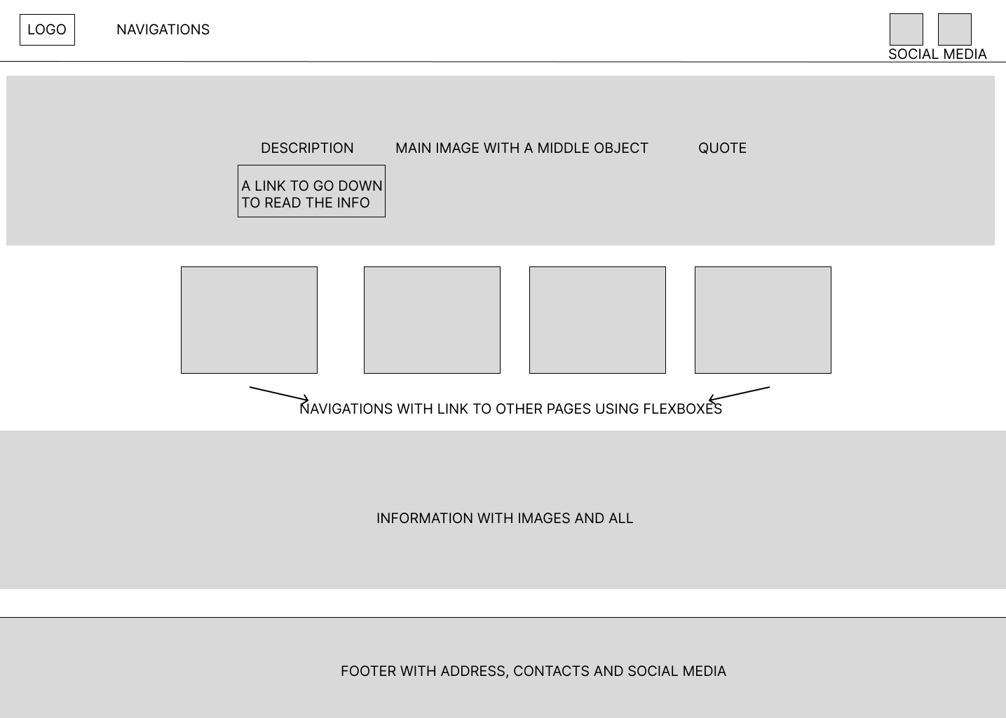

## Introduction

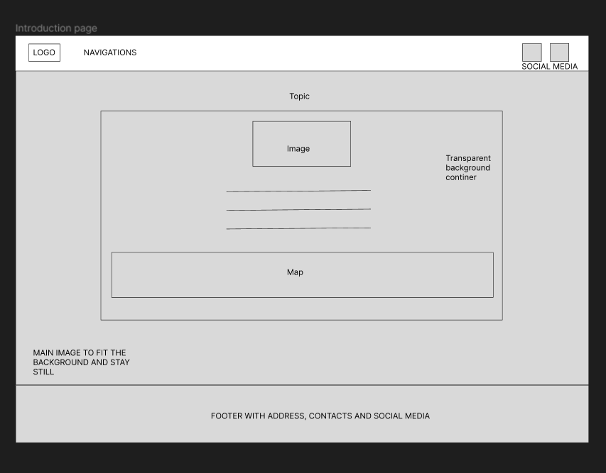

## Department Of Wildlife Conservation

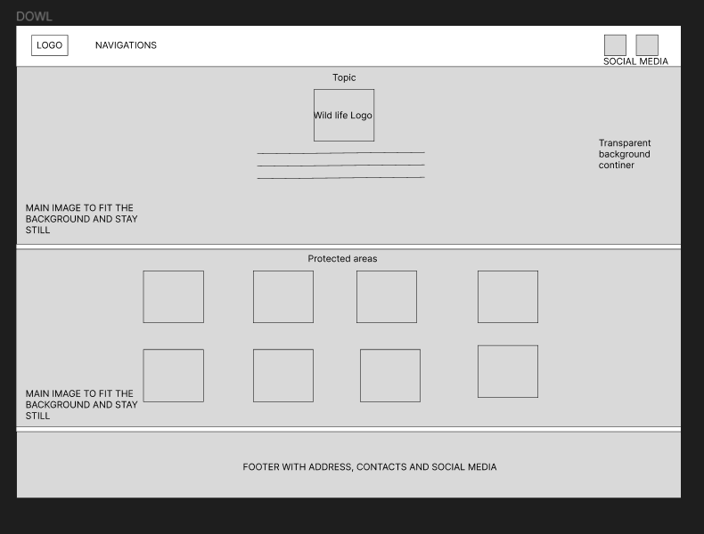

## Leopards

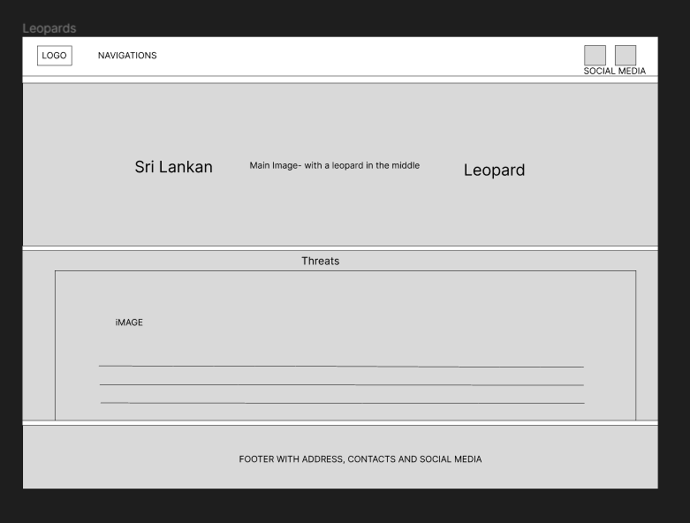

## Indigenous Animals

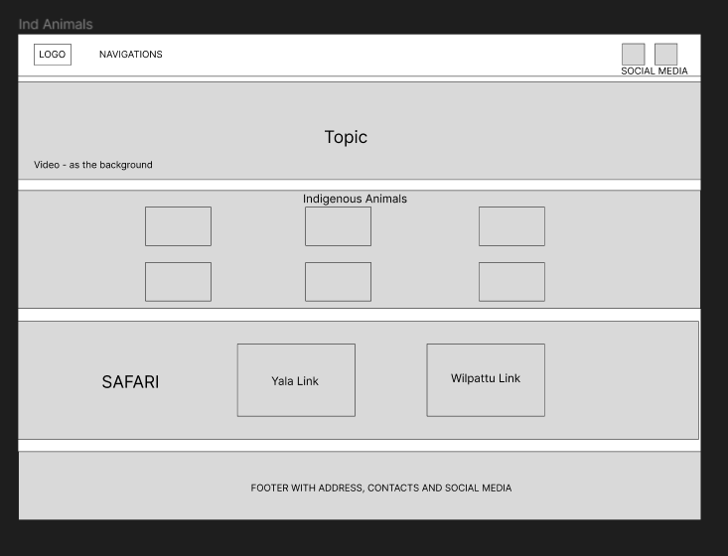

## Yala National Park

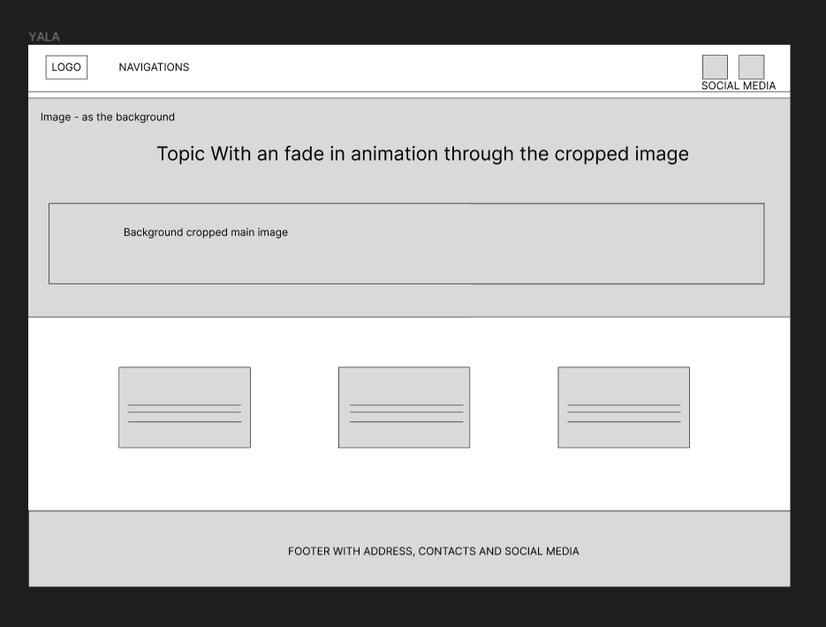

## Wilpattu National Park

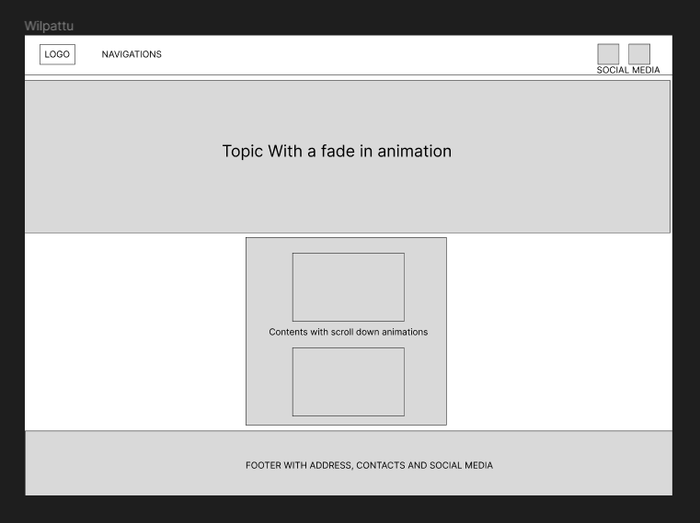

# Mobile Wireframes

## Home page

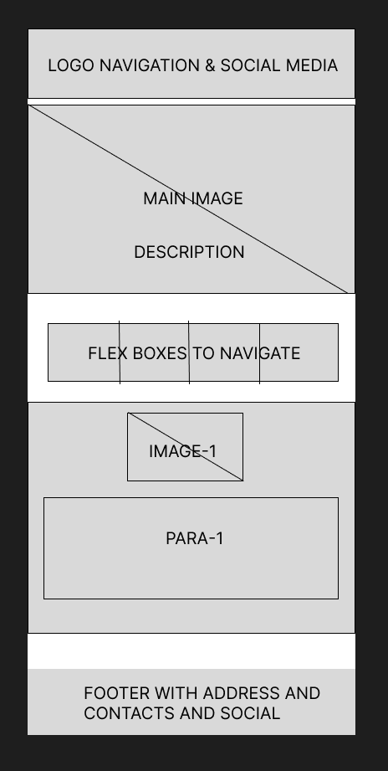

## Introduction

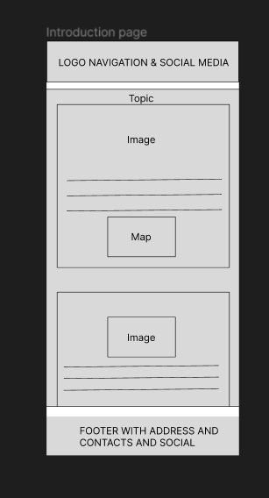

## Department Of Wildlife Conservation

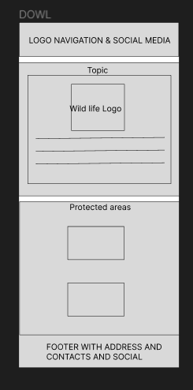

## Leopards

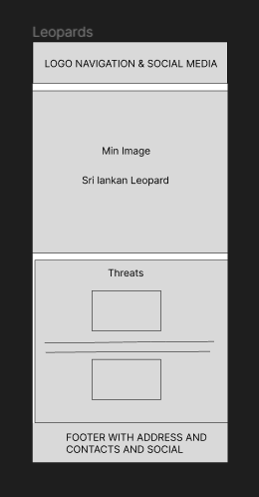

## Ind Animals

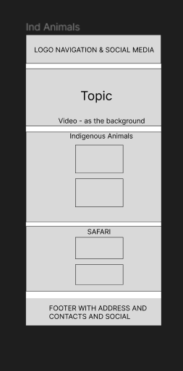

## Yala National Park

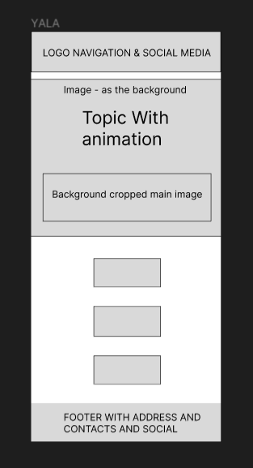

## Wilpattu National Park

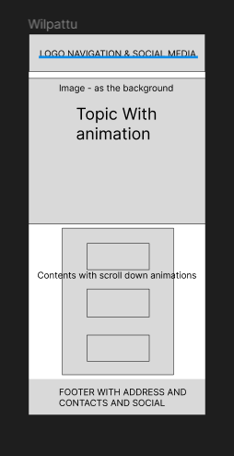

# 

# Conclusion

In conclusion, this project has been a very good experience. It provided deeper knowledge in creating responsive and maintaining a creative designs, understanding the importance of semantic HTML and overcoming challenges such as time management.

Acknowledgment

I would like to express my gratitude to the lecturer Mr. Pradeep who was a helping hand, the online resources such as the unsplash free stock website, Sri Lankan tourism websites etc and youtuber Danni Krossing who made HTML and CSS a lot easier to understand through his videos, which contributed to the successful completion of this assignment. Additionally, the challenges I faced strengthened my problem soliving skills and sharpened my understanding of HTML, CSS and Java script.

Afzal Jazeel

CB013131